Design Thinking

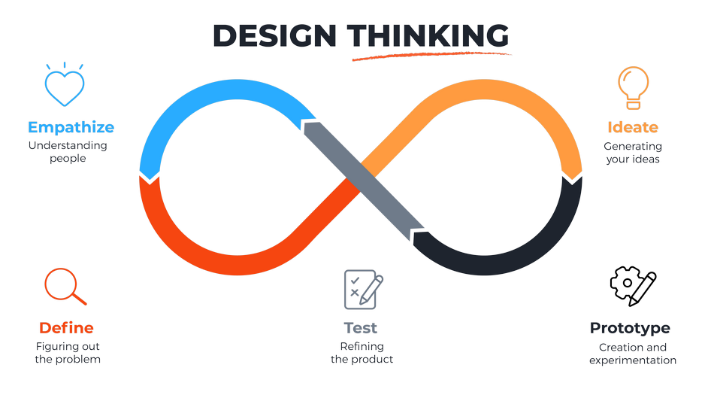

Date : 11.02.2022

Version : 0.3

Authors : Aleksandar Hadzhiev and Felix Morenc

Version history

|  |  |  |  |
| --- | --- | --- | --- |
| Version | Date | Author(s) | Changes |
| *0.1* | *09.02.2022* | *Aleksandar Hadzhiev* | *Initial Version* |
| *0.2* | *10.02.2022* | *Aleksandar Hadzhiev* | *Adding Ideation and Prototyping* |
| *0.3* | *11.02.2022* | *Felix Morenc* | *Refined Ideation, prototyping and added Testing* |

Table of Contents

1. Empathize 3

2. Define 4

3. Ideation 4

4. Prototype 6

• Idea 1 6

• Idea 2 6

• Idea 3 7

6. References 14

# Empathize

At the beginning we received the topic for our project and a persona, to give us path, which we should work on for this project. The topic was sports, and the persona was [Caring grandmother Anita](https://fhict.instructure.com/courses/12038/modules/items/746849).

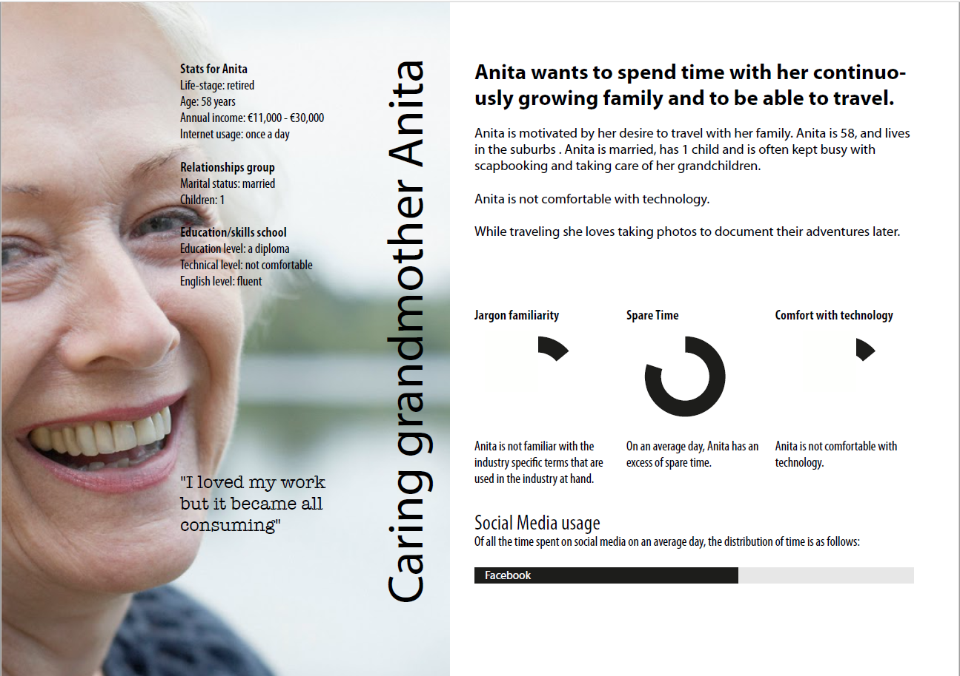

From the topic we understood that the direction of this project is sports and from the persona we understood that the focus group is elderly people. The persona was not enough so we did research on our own about old people and their thoughts on sports (*Literature study*), here is what we found out:

|  |  |
| --- | --- |
| Positive factors | Negative factors |
| *Better health* | *Self-efficacy* |
| *Better aging* | *Fear of Injury* |
| *Socializing* | *Inertia* |
| *Improve family relationships* | *Depression and Anxiety* |
| *Competition/achievements* | *Self-conscious* |
|  | *Health Problems* |
|  | *No Time* |
|  | *Lack of Knowledge* |
|  | *Lack of Support* |

What we can see is that there are more negative aspects which they associate with sports than positive, but there is a chance for them to start doing sports.

# Define

Now that we have better knowledge on what older people think about sports, we must define a problem, which this project will have for a goal to solve. What we found (*Literature study*), is that there is not a single problem to be fixed, if we would like for older people to do more sports, but a chain of smaller ones, which are:

* Health
* Want to spend time with family
* Low income
* Low technological literacy
* Want to be more social
* Motivation

Together these problems formulated the main problem for this project: *“How can we encourage people of retirement age to go do more sports”*

Of course, to solve the main problem, we first had to find a way to fix the smaller ones.

# Ideation

Now that we knew what the problem/s this project will have to solve, we could start thinking of ways to solve them. We used *Literature study*, *Best, good, and bad practices, Brainstorming*. What we found during our research is that there are a lot of existing apps, which are in the sports sphere and have for a goal to help people exercising using different methods, but could not solve the problem we have in front of us. We also found certain methods, which could help us achieve our goal for this project. Here are the methods and existing apps, which we found in our research:

|  |  |
| --- | --- |
| Existing apps | Methods to solve the problem |
| *Fioecracy* | *Find Simple Ways to Make Exercise Fun and Enjoyable* |
| *Fleetly* | *Find Ways to Fit Exercise into Your Day* |
| *FigureRunning* | *Make Exercise a Social Activity* |
| *Teemo* | ***Track your progress*** |
| *RunKeeper* | *Set some goals* |
| *JEFIT Workout* |  |
| *Yoga Studio* |  |

The apps are just some of many out there and the methods are the most mentioned ones.

Now that we knew what apps existed and what they did and some methods, which could help us solve the problem we started thinking of idea, which could have in mind what the apps lacked and how to use the methods with it. We thought of 2 ideas of how to tackle the problem: *Idea 1 Jogging/Hike Tracker*and *Idea 2 Outside Exercise Organization App for Old People.*

After comparing the two we decided to go with Idea 2 and after some feedback from our teachers we decided to tackle idea 2 differently and choose only one of the many functionalities the idea proposed. Therefore, the final idea we have for this project is: *Session creating app.*

The app will allow the users to create and join sessions, where they could exercise together with people, which have the same interests as theirs. Later we decided that the app will support the users using a virtual “coach.” The virtual “coach” will have for a job to ask them to join sessions if they have already not and encourage them when they do. The main goal of the application is to keep doing sports social as much as possible, which was the main thing which the older people mention for a reason to start doing sports or lose motivation and stop (if there is not socializing).

Upon even further research, however, we decided to change the idea we were going with. There were several reasons for this, to start we determined that the platform idea would be difficult to implement without an existing userbase, making testing and potentially releasing the application difficult. Another reason was that the app itself has many alternatives, such as Facebook, who already do what we are trying quite well. Finally, the app itself really lacked any playful aspect to it, which made really motivating the users difficult.

|  |  |  |
| --- | --- | --- |
| Playful Experience | Ideas | Final Takes For MVP |
| *Challenge* | *Daily, Weekly, Monthly challenges* | *Daily* |
| *Competition* | *Leaderboard, Competing with yourself from yesterday* | *Competing with yourself from yesterday* |
| *Completion* | *Small rewards, big rewards, Points* | *Small rewards* |
| *Discovery* | *New ways of exercising* | *New ways of exercising* |
| *Fellowship* | *Clan/Team, Team battles* |  |

We did some more brainstorming and produced a final new idea, which was a platform that provides the user with some daily exercise tasks, allowing them to then complete these tasks and earn daily score to track how active they are, while also motivating them to exercise more in a playful and informative way.

# Prototype

After we have set a plan which we wanted to follow, we started sketching to see how the app will look like and had 3 ideas of how the app should look like, note that these sketches were made for idea 2, which was the exercise organization platform and not the final idea of a daily exercise task app:

### Idea 1

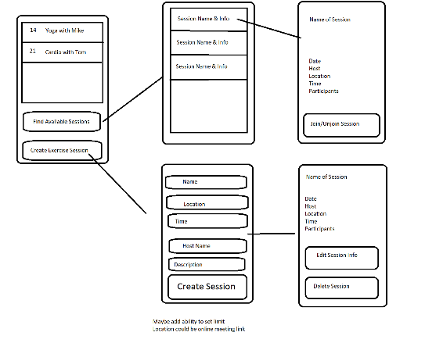

### Idea 2

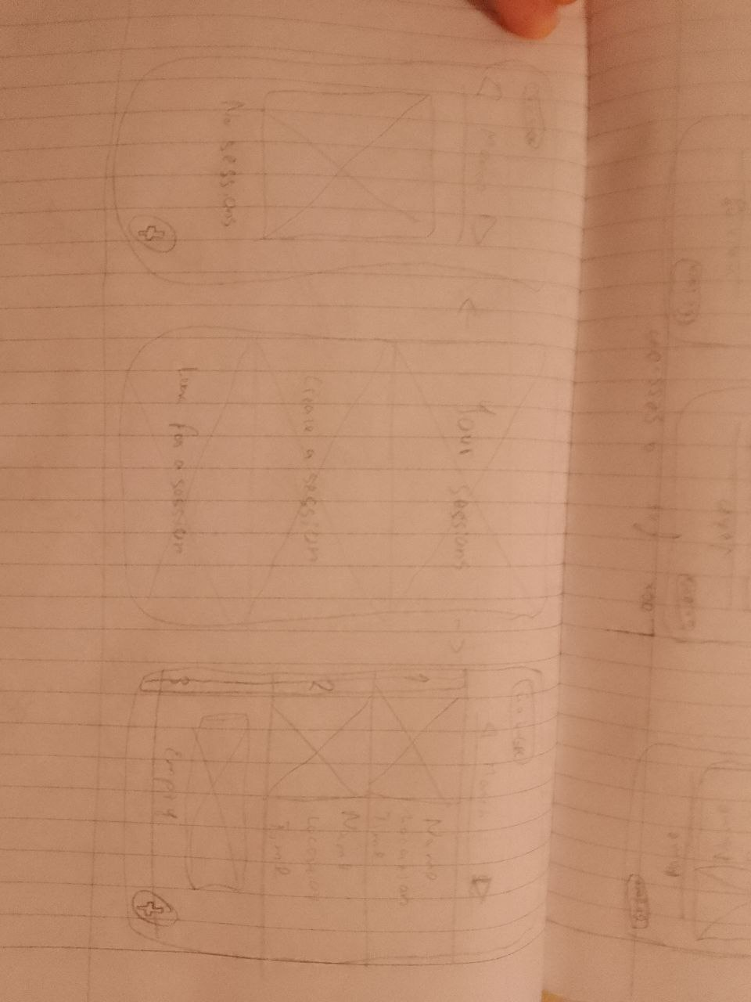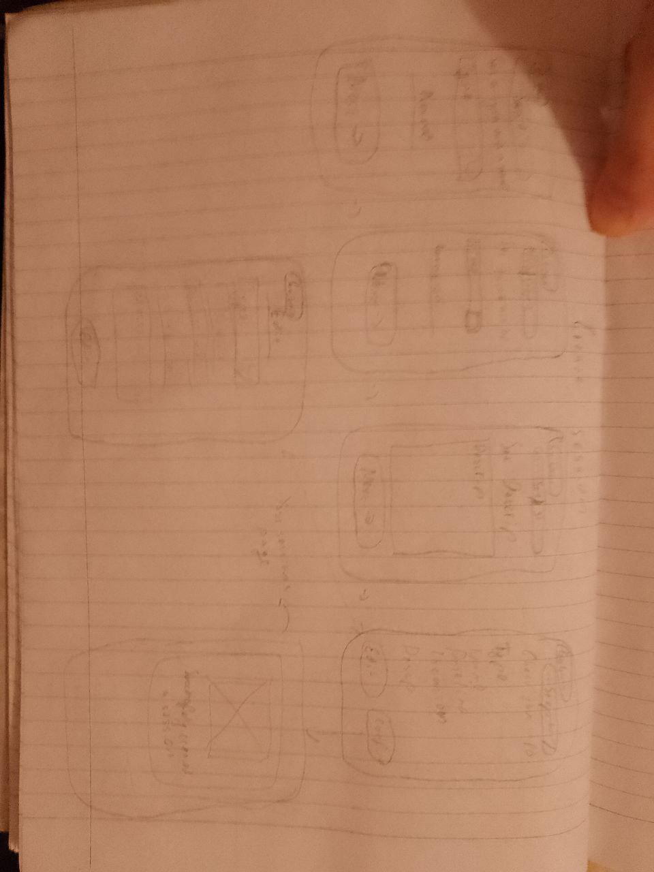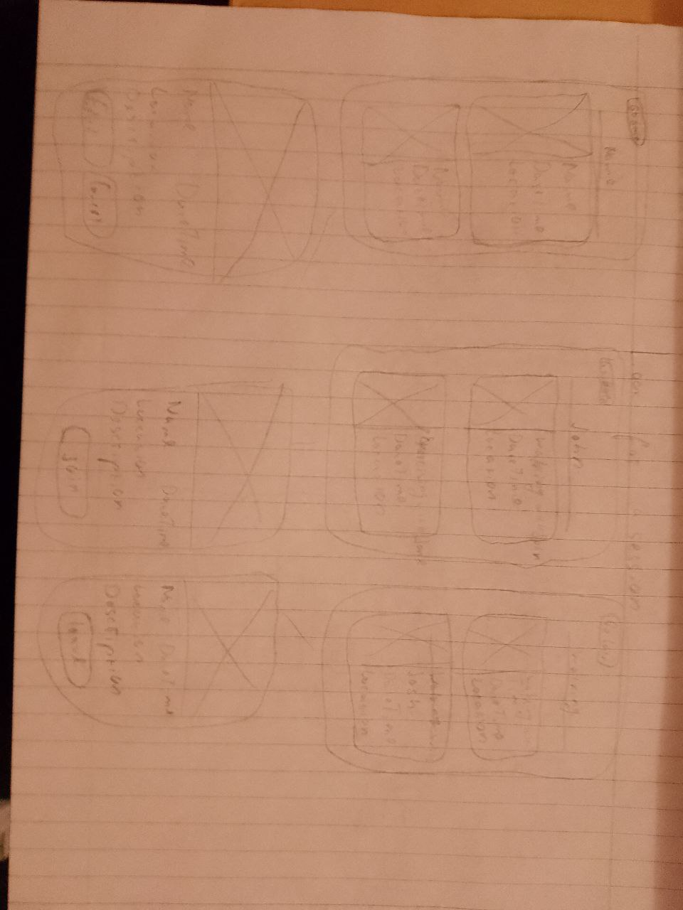

### Idea 3

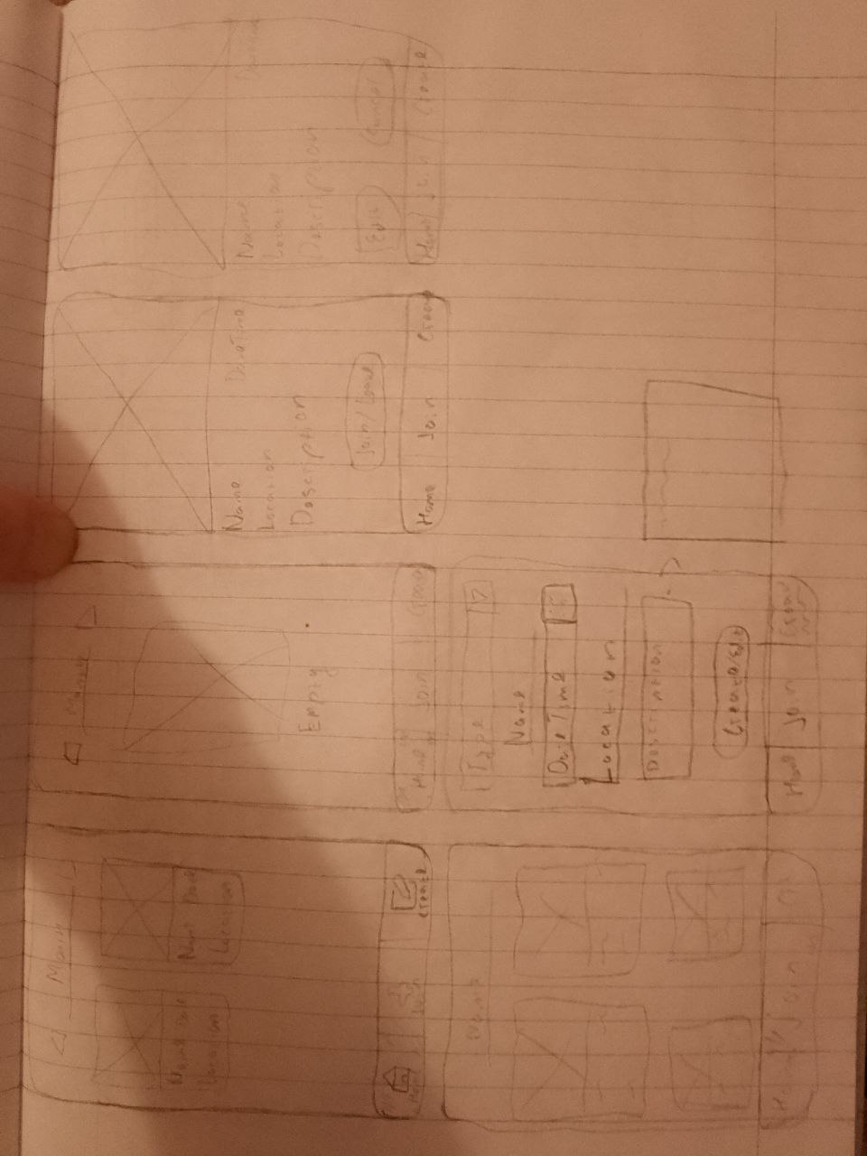

We did *A/B testing* and after comparing the 3 sketches we decided to continue with idea 3, mostly because it had the least busiest screens interfaces.

After that we made a wireframe view for each of the pages:

* Homepage

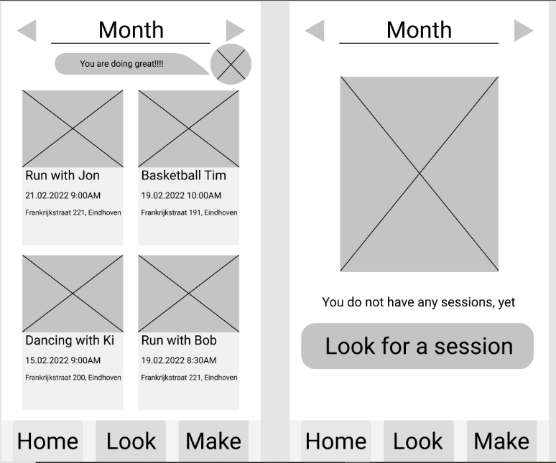

* Search page

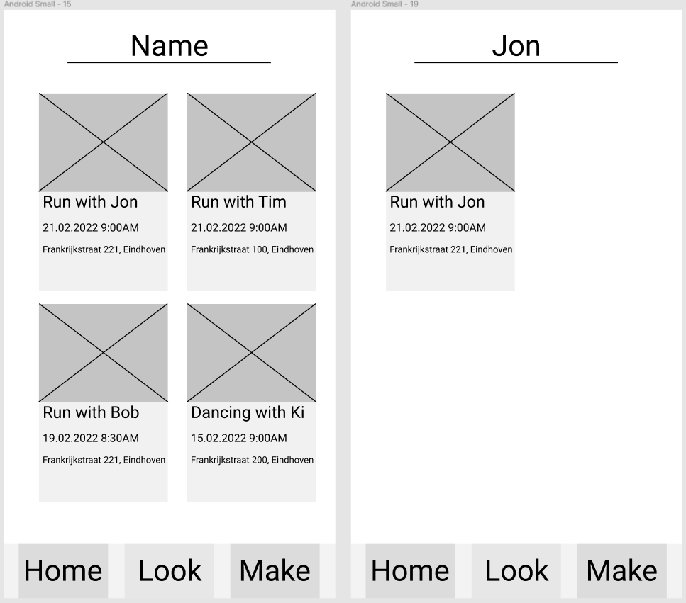

* Make (Create)/Edit page

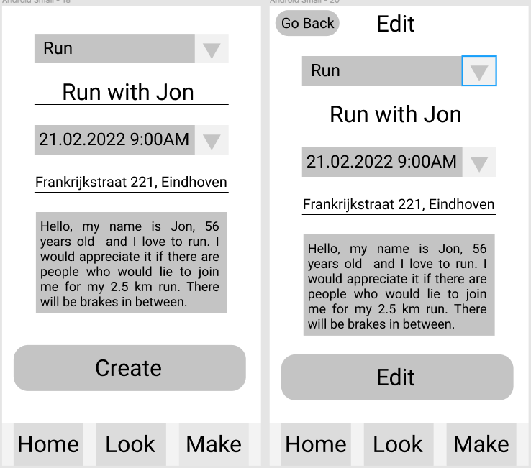

* Session page

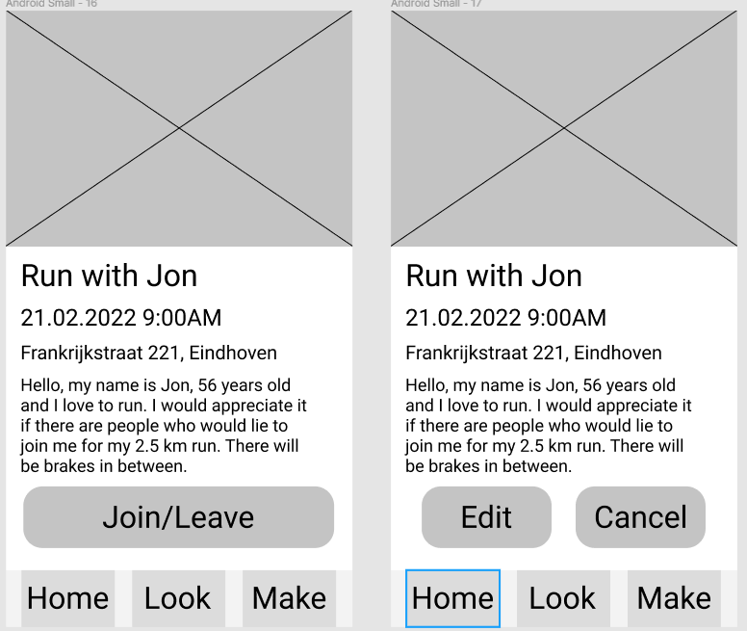

After the wireframe we worked on the complete design of the application and at the end it looked like this:

* Homepage

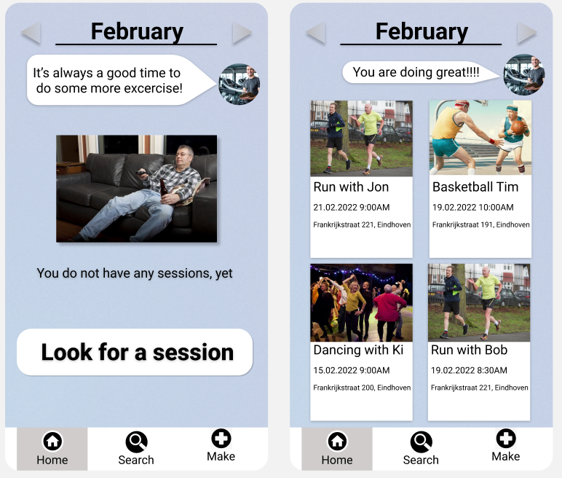

* Search page

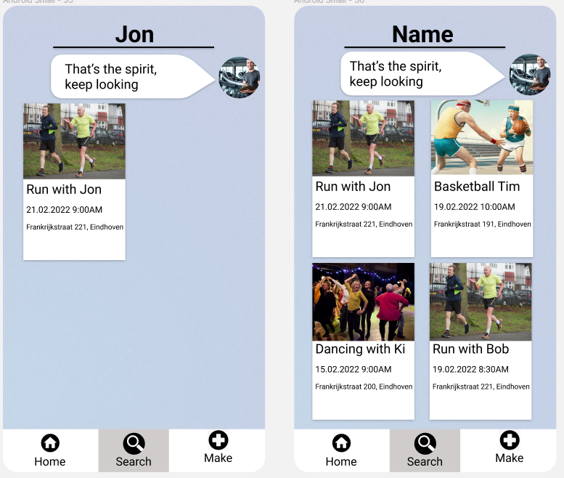

* Make (Create)/Edit page

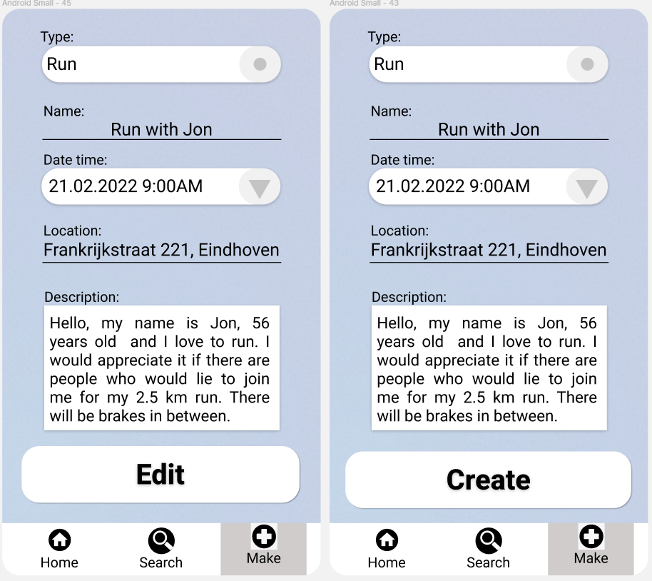

* Session page

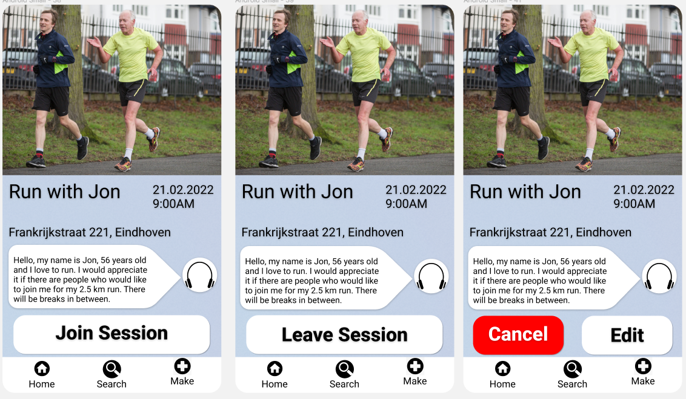

We did a little research on what colors to use for the application to look more welcoming and calmer to the users and found out that light blue is a color which is welcoming and calm for the users. After changing the idea which we are aiming to achieve we did a small sketch on the basic idea of the application and a design in Figma:

* Sketch

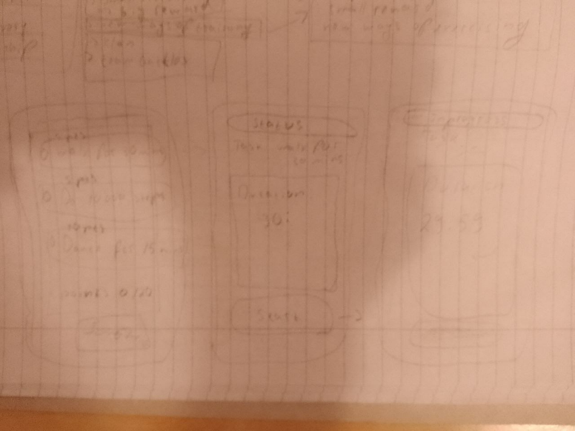

* Homepage

1. Still doing

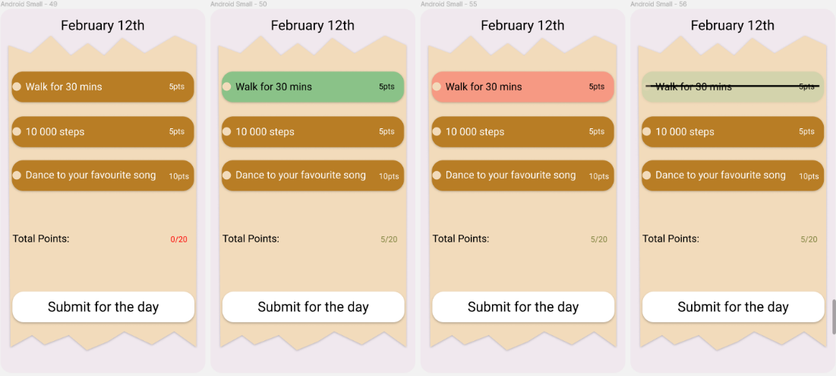

1. Completed

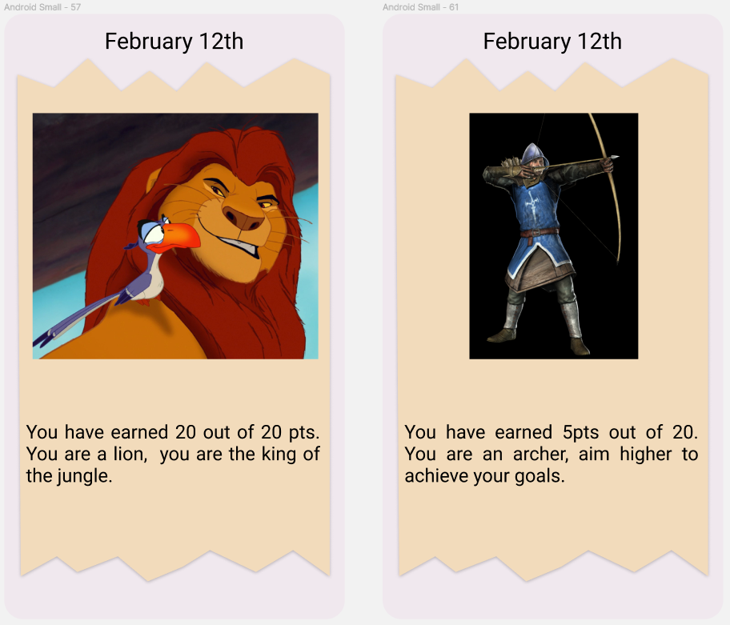

* Task Page

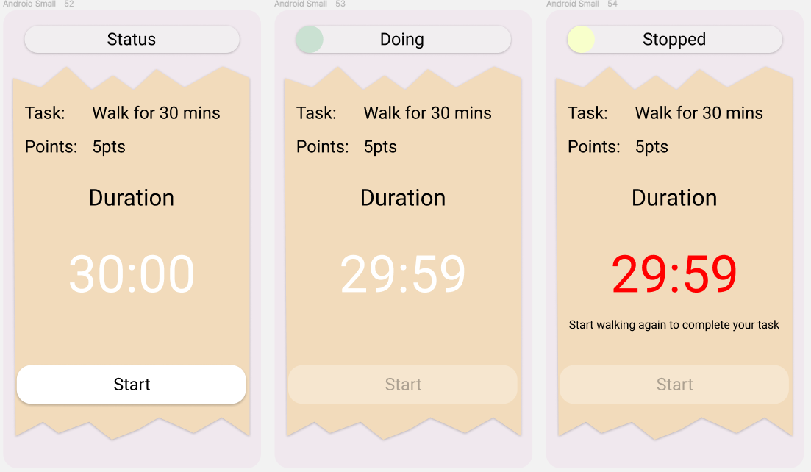

1. Testing

Due to the time constraints of this project, only being 1 weeklong, the testing that was performed was quite limited and means there is more that could be discovered with a longer testing period. In our case the testing consisted solely of getting feedback from our instructor, who falls near the target demographic of users of the app.

The main point that was received was that the app needed to be a bit more motivational when conveying results to the user. In the initial prototype the app told users they could do better if they did not achieve maximal score. Instead, the app should inform the user about how good of a job they are doing by even completing any tasks, working by feeding the user more positive reinforcement on their exercise routines

Another aspect that was changed was the images displayed. In the initial prototype they were quite bland and not remarkably interesting. From the testing we were able to determine that we could make the image more playful by making it an interactive model potentially, and this was then applied to the prototype successfully.

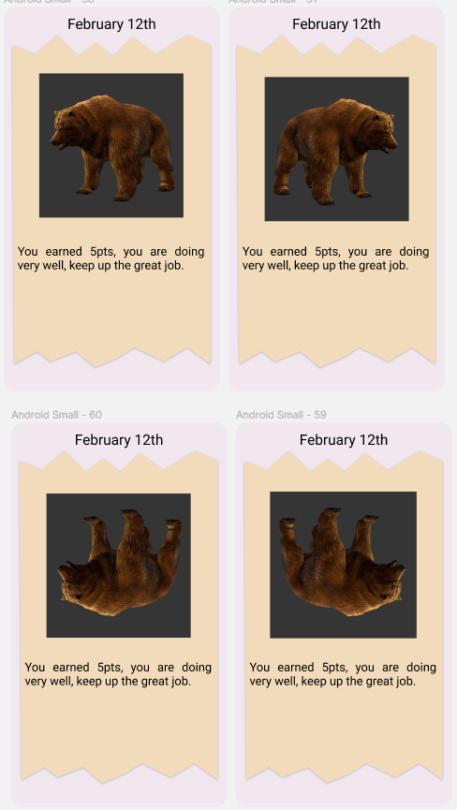

# References

Stenner, B. J., Buckley, J. D., & Mosewich, A. D. (2020, December). *Reasons why older adults play sport: A systematic review*. Journal of sport and health science. Retrieved February 10, 2022, from <https://www.ncbi.nlm.nih.gov/pmc/articles/PMC7749227/>

Jena Walther, M. S. (n.d.). *Are older adults indifferent, scared, and reluctant to exercise?* NASM. Retrieved February 10, 2022, from <https://blog.nasm.org/uncategorized/are-older-adults-indifferent-scared-and-reluctant-to-exercise>

*Learning note: Older people and sport - sportscotland*. (n.d.). Retrieved February 10, 2022, from <https://sportscotland.org.uk/media/2595/learning-note-older-people-and-sport.pdf>

Jenkin, C. R., Eime, R. M., Westerbeek, H., O’Sullivan, G., & van Uffelen, J. G. Z. (2017, December 22). *Sport and ageing: A systematic review of the determinants and trends of participation in sport for Older Adults - BMC Public Health*. BioMed Central. Retrieved February 10, 2022, from <https://bmcpublichealth.biomedcentral.com/articles/10.1186/s12889-017-4970-8/tables/2>

Alsever, J. (2013, July 24). *Apps to help motivate you to exercise*. The Wall Street Journal. Retrieved February 10, 2022, from <https://www.wsj.com/articles/SB10001424127887324328904578622450639411298>

*10 fitness apps to encourage physical activity*. Clinical Advisor. (2018, December 19). Retrieved February 10, 2022, from <https://www.clinicaladvisor.com/slideshow/slides/10-fitness-apps-to-encourage-physical-activity/>

Herrfeldt, K. (2018, November 19). *5 ways to motivate seniors to get more exercise*. Home Care Assistance Sacramento. Retrieved February 10, 2022, from <https://www.homecareassistancesacramento.com/motivating-elderly-people-to-exercise/>

U.S. Department of Health and Human Services. (n.d.). *Staying motivated to exercise: Tips for older adults*. National Institute on Aging. Retrieved February 10, 2022, from <https://www.nia.nih.gov/health/staying-motivated-exercise-tips-older-adults>

Usa, H., Bolthouse, T., & Alkire, S. (2022, February 9). *4 ways to help seniors tap into lifelong motivation for exercise*. HUR USA - FOR LIFELONG STRENGTH. Retrieved February 10, 2022, from <https://www.hurusa.com/4-ways-to-help-seniors-tap-into-lifelong-motivation-for-exercise/>

The National Council on Aging. (n.d.). Retrieved February 10, 2022, from <https://www.ncoa.org/article/5-tips-to-help-older-adults-stay-motivated-to-exercise>

Brett, T. (2017, November 21). *Motivation techniques for football*. Chron.com. Retrieved February 10, 2022, from <https://livehealthy.chron.com/motivation-techniques-football-3240.html>

*7 color palettes that can improve your mood*. Beezzly. (2021, August 11). Retrieved February 10, 2022, from <https://beezzly.com/color-palettes-that-can-improve-your-mood>

*What colors make you happy? 7 colors that boost your mood*. Color Meanings. (2021, October 3). Retrieved February 10, 2022, from <https://www.color-meanings.com/happy-colors-boost-mood/>